**EE307 assignment10 Homework**

12112441 曹子惠

Question：

Write a (Matlab) program to plot 2D pattern of a linear array

1. Test program using a 10 element array spaced at λ/2.
2. Show phase shift changes the main beam direction

Answers:

Use the code below to program using a 10 element array spaced at λ/2:

%% Array Properties

SubObject = design(dipole, 2400*1e6);

arrayObject = design(linearArray('Element', SubObject), 2400*1e6, SubObject);

arrayObject.NumElements = 10;

arrayObject.ElementSpacing = 0.0625;

%% Array Analysis

% Show for linearArray

figure;

show(arrayObject)

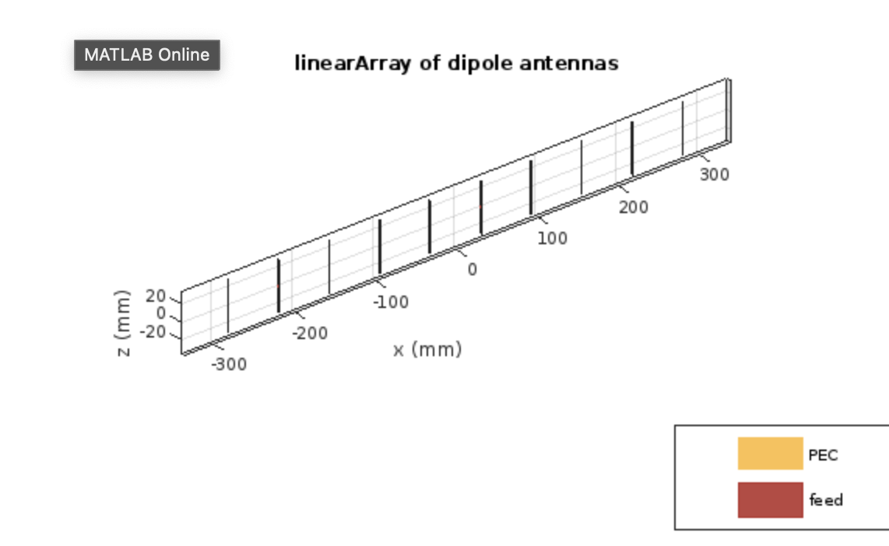

1. Plot 5 figures to show phase shift changes:

for i=0:4

theta = linspace (0,2*pi,100);

N=10;

fi =pi*cos(theta)+i*pi/2;

AF =sin(N*fi/2)./(N*sin(fi/2));

figure

polarplot(theta,AF);

switch i

case 0

title('phaseshift= 0');

case 1

title('phaseshift= pi/2');

case 2

title('phaseshift= pi');

case 3

title('phaseshift= 3*pi/2');

case 4

title('phaseshift= 2*pi');

otherwise

break

end

end

